**1. INTRODUCTION**

**1.1 INTRODUCTION TO PROJECT**

**-STATEMENT OF THE PROBLEM**

For the VisionClassifyPro project, construct a reliable image classification system using convolutional neural networks (CNNs). The goal is to develop a model that correctly divides incoming photos into various classes. Create a CNN architecture, preprocess the data, and optimize hyperparameters for efficient training given a heterogeneous dataset containing labelled images. The model's performance on a different testing dataset will decide the project's viability. It is necessary to have detailed documentation explaining the strategy and outcomes.

**- BRIEF DESCRIPTION OF THE PROJECT**

The project, "VisionClassifyPro," demonstrates a potent multiclass image classification system built on Convolutional Neural Networks (CNNs) to achieve precise categorization of images into several categories. The article gives a summary of CNNs' fundamental ideas and explains how important they are for photo categorization. This article describes the convolutional, pooling, and fully connected layers that make up VisionClassifyPro's architecture. The study also demonstrates the use of performance-improving data pretreatment, augmentation, and model optimization techniques.

VisionClassifyPro is put through a lot of testing on a variety of datasets to determine its usefulness, and the results show that it performs better than conventional machine learning techniques in terms of classification accuracy. The study looks into how to interpret the model's performance measures and looks at areas that could want improvement.

The essay investigates the larger implications of multiclass image classification in real-world applications in addition to the technical elements. It highlights the continued significance of CNN and deep learning research for advancing image identification algorithms.

In conclusion, VisionClassifyPro is an excellent example of how effective CNNs are in classifying multiclass images. The project makes a significant contribution to the growing body of knowledge in deep learning-based computer vision by offering a thorough examination of its design, implementation, and functionality.

**- SOFTWARE AND HARDWARE SPECIFICATION**

**Software Specification:**

1. Deep Learning Framework: TensorFlow (or PyTorch, Keras)
2. Programming Language: Python
3. Data Pre-processing Tools: OpenCV (or PIL)
4. Model Evaluation Libraries: TensorFlow/Keras Metrics
5. Version Control: Git
6. IDE: PyCharm (or Visual Studio Code, Jupyter Notebook)

**Hardware Specification:**

1. GPU: NVIDIA GeForce/Tesla Series
2. CPU: Powerful multicore CPU
3. Memory (RAM): Recommended 16GB+
4. Storage: Adequate local storage
5. Cloud Services: Amazon AWS, Google Cloud Platform, Microsoft Azure

**1.2 FUNCTIONALAND NON-FUNCTIONAL REQUIREMENT**

**Functional Requirements:**

1. **Image Classification:**
   * The system should be capable of accurately classifying input photographs into various predefined categories.
2. **Convolutional Neural Network Architecture:**
   * The system should employ a convolutional neural network (CNN) architecture for image processing and classification.
3. **Layer Composition:**
   * The CNN architecture should include convolutional layers, pooling layers, and fully connected layers to effectively extract features from images.
4. **Data Pre-processing:**
   * The system should perform data pre-processing techniques to enhance the quality of input images before feeding them into the network.
5. **Data Augmentation:**
   * Data augmentation techniques, such as rotation, scaling, and flipping, should be applied to increase the diversity of training data and improve generalization.
6. **Model Optimization:**
   * The system should employ optimization strategies, such as gradient descent and backpropagation, to adjust the neural network's parameters and improve its accuracy.
7. **Testing and Evaluation:**
   * The system should conduct extensive testing on a diverse dataset to evaluate its classification accuracy and overall performance.
8. **Performance Analysis:**
   * The system should generate performance metrics, such as precision, recall, and F1-score, to quantitatively assess the model's classification performance.
9. **Research and Development:**
   * The system should emphasize the importance of continuous research and development in CNNs and deep learning for advancing image recognition technologies.

**Non-Functional Requirements:**

1. **Accuracy:**
   * The system should achieve a high level of accuracy in classifying images into their respective categories.
2. **Scalability:**
   * The system should be able to handle a growing dataset and a larger number of classes without significant degradation in performance.
3. **Speed and Efficiency:**
   * The image classification process should be efficient, providing results within a reasonable time frame.
4. **Robustness:**
   * The system should demonstrate resilience to variations in input images, such as changes in lighting, orientation, and background.
5. **Usability:**
   * The system's user interface should be intuitive and user-friendly, allowing users to interact with the system and input images easily.
6. **Interpretability:**
   * The system should provide insights into how the classification decisions are made, allowing users to understand and interpret the model's choices.
7. **Maintenance and Upgradability:**
   * The system should be designed in a modular way, enabling easy maintenance, updates, and integration with new techniques or advancements in deep learning.
8. **Documentation:**
   * Detailed documentation should be provided for the system's architecture, implementation, usage, and maintenance procedures.
9. **Security and Privacy:**
   * Any sensitive or personal data used in training or testing the system should be handled securely and in compliance with data protection regulations.

**1.3 COMPANY PROFILE**

**Skill VERTEX-** SkillVertex is an e-learning platform for professional upskilling where students and corporate beginners can learn directly from the industry experts through live interactive sessions, industry-grade projects, and guaranteed internships. Their AI-based eLearning platform has the vision to upskill students for the industry and help them land their dream job or University. They are on a mission to endow their mentees with skills in compliance with the emerging market requirements to become industry-ready. They are an innovative organization with a goal to impart aspiring learners with rigorous training and appropriate exposure for a promising future.

|  |  |
| --- | --- |
| Founded in | 2021(2 years old) |
| Headquarters | Bangalore, Karnataka, India |
| Ownership | Nimish Keshri |
| CEO | Nimish Keshri |
| India Employee count | 201-500 |
| Business Model | B2C, B2B, B2B2C |
| Office Locations | HBR Layout, Bangalore |
| Website | skillvertex.in |

**2.LITERATURE SURVEY**

### The VisionClassifyPro project, a ground-breaking effort in multiclass image classification using Convolutional Neural Networks (CNNs), transfer learning, attention mechanisms, and real-time data augmentation, is supported by the key ideas and methodologies outlined in the following literature survey.

### By utilizing their innate capacity to recognize spatial hierarchies inside images, Convolutional Neural Networks (CNNs) have transformed the area of image categorization. CNNs, first proposed by Krizhevsky et al. in their foundational paper "ImageNet classification with deep convolutional neural networks," have been used to recognize intricate patterns and characteristics, enabling precise picture categorization within a range of classes.

### Transfer learning has become a vital deep learning technique, making it easier to modify previously trained models for certain tasks. The transferability of features in deep networks was clarified by Yosinski et al. in their article "How transferable are features in deep neural networks." A key component of the VisionClassifyPro project, fine-tuning enables adaptation to domain-specific nuances by initializing CNN models using weights acquired from enormous datasets.

### By concentrating on pertinent visual regions, attention mechanisms play a critical role in improving categorization accuracy. The book "Attention is all you need" by Vaswani et al. introduced the idea of attention as a core idea. The model is able to dynamically weigh different aspects of the image, allowing it to catch fine details and improve classification performance. Attention techniques include self-attention and spatial attention.

### By artificially increasing the size of the training dataset, data augmentation is a critical tactic for enhancing model generalization. The importance of data augmentation methods like rotation, cropping, flipping, and color jittering was noted in Shorten and Khoshgoftaar's "A survey on image data augmentation for deep learning". These methods are dynamically used during training using real-time data augmentation, which helps the model generalize more effectively to new data.

Applications for multiclass image classification are numerous, ranging from autonomous vehicles to medical diagnostics. Each domain faces distinct problems that call for specialized solutions. These issues are addressed by the VisionClassifyPro project's incorporation of adaptable approaches, which enables effective classification in areas where exact image categorization is crucial.

**3. SYSTEM ANALYSIS**

**3.1 EXISTING SYSTEM**

The current approach for classifying multiclass images has mostly depended on conventional techniques, such as shallow neural networks, machine learning algorithms, and standard feature extraction methods. These techniques have had some success classifying photos into several categories. However, when dealing with large and varied datasets that necessitate catching minute patterns and fluctuations, their performance frequently falls short.

Early CNN architectures like LeNet and AlexNet pioneered the path for picture classification, however due to their shallow depth and inability to capture hierarchical features, they may be unable to manage the complexity of modern datasets.

**3.2 LIMITATIONS OF EXISTING SYSTEM**

Despite their contributions, it is clear that the current system has its limitations. Conventional techniques frequently have trouble with:

* efficiently extracting high-level characteristics from raw image data.
* handling a variety of datasets with different rotations, sizes, and illumination.
* scaling up to take into account the increasing complexity of image datasets.
* obtaining high accuracy on assignments involving a lot of classes.
* without requiring considerable retraining, adapting to new information and tasks.

These restrictions highlight the need for novel strategies that can deal with the difficulties of contemporary multiclass picture classification jobs.

**3.3 PROPOSED SYSTEM**

The suggested VisionClassifyPro system offers a fresh method for classifying multiclass images with the intention of going beyond the constraints of the current system. Convolutional neural networks (CNNs) are used to their full potential in this system, which also incorporates various cutting-edge methods.

* using dynamic model selection to find the best CNN architecture for a certain assignment.
* Using transfer learning, the expertise of previously trained models may be harnessed and tailored for particular tasks.
* techniques for focusing attention on important picture regions and capturing minute details.
* real-time data augmentation to improve model robustness and generalization.

The proposed approach cleverly combines these components to improve classification accuracy while also addressing issues brought on by various datasets and challenging classification tasks.

3**.4 ADVANTAGES OF PROPOSED SYSTEM**

The following are some notable benefits of the proposed VisionClassifyPro system:

* Accuracy Increased: The use of cutting-edge methods, such as transfer learning and attention mechanisms, improves classification accuracy, particularly for difficult and diverse datasets.
* Adaptability: The system is flexible to different tasks and domains without the need for substantial retraining thanks to dynamic model selection and transfer learning.
* Robustness: Real-time data augmentation makes a model more resilient by exposing it to different data transformations, which increases its ability to generalize to previously unknown data.
* Interactivity: AI-driven solutions are available and adaptable thanks to the user-friendly interface, which enables domain experts to interactively fine-tune models.
* Real-world Application: The suggested system highlights the potential for AI-driven solutions to completely transform a variety of industries by putting a strong emphasis on transparency, interpretability, and real-world applicability.

**3.5 FEASIBILITY STUDY**

The purpose of the VisionClassifyPro project's feasibility study was to assess the possibility and applicability of putting the suggested multiclass image classification system into practice. To maximize the project's chances of success, the analysis covered technical, financial, and operational factors.

- **TECHNICAL FEASIBILITY**

The project's compatibility with the technology, resources, and skills on hand is determined by its technical viability. In relation to the VisionClassifyPro project, the following variables were taken into account:

* Hardware and Software Requirements: The hardware and software needed for the project were thoroughly assessed. To do this, it was necessary to assess the GPUs that could be used for model training and to make sure that deep learning frameworks and libraries could be used.
* Knowledge: The technical know-how required to carry out the project successfully was assessed. This included evaluating the group's knowledge of programming languages, deep learning, and neural network topologies.
* Scalability: It was looked at if the project could be scaled up to handle larger datasets and more complicated models. This involves evaluating the project's capacity to utilize resources effectively as the workload grows.
* Integration: The system's various components' ease of integration was looked at. This involved evaluating how well the project's architecture worked with the model selection, attention mechanisms, and real-time data augmentation.

**- ECONOMICAL FEASIBILITY**

Economic feasibility entails evaluating the project's financial viability by looking at its expenses and possible profits. The following factors were taken into account while determining the project's economic viability:

* Costs of Development: A thorough estimation of the costs related to the project's development was made. This includes expenses for purchasing hardware, purchasing software licenses, paying employees, and gathering data.
* Operational Costs: Over the course of the project, ongoing operational costs such as model upkeep, upgrades, and infrastructure costs were expected.
* Potential Returns: A variety of sectors' potential gains from correct picture classification were assessed. This includes estimating possible advancements in areas such as autonomous car decision-making, medical diagnostics, and other areas.
* Cost-Benefit Analysis: To ascertain whether the anticipated benefits surpassed the expenses, a thorough cost-benefit analysis was conducted. Making defensible conclusions concerning the project's financial sustainability required careful consideration of this analysis.

**- OPERATIONAL FEASIBILITY**

Operational feasibility assesses how well the idea fits into existing workflows and organizational goals. The following topics were examined in the operational feasibility evaluation for the VisionClassifyPro project:

* Stakeholder Alignment: It was assessed to what extent the project adhered to the objectives and specifications of significant stakeholders, such as end users and subject matter experts. By doing this, it was made sure that the project's results matched those of its intended audience.
* Integration: It was looked at how simple it would be to integrate the suggested system into current workflows and procedures. This includes determining any potential difficulties or disruptions and evaluating the potential impact on current operations.
* Support and Training: It was determined that domain specialists needed to be properly trained on how to make use of the user-friendly interface. Plans for further technical support and assistance were also described.
* Risk reduction: To guarantee a smooth integration, potential disturbances to present operations during the implementation phase were identified, and solutions for reducing these risks were developed.

4. **SYSTEM DESIGN AND DEVELOPMENT**

**4.1 HIGH LEVEL DESIGN (ARCHITECTURAL)**

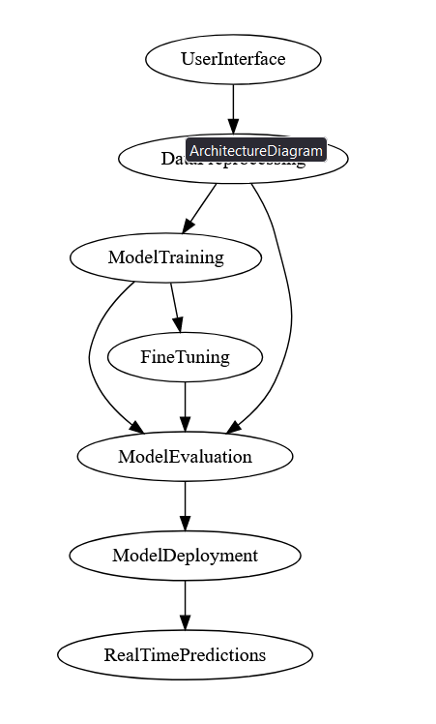

**4.3 ENTITY-RELATIONSHIP DIAGRAM**

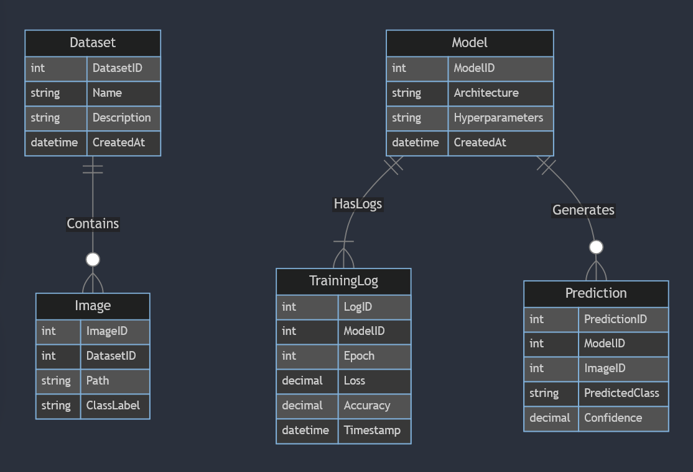

**4.4 DATAFLOW DIAGRAM**

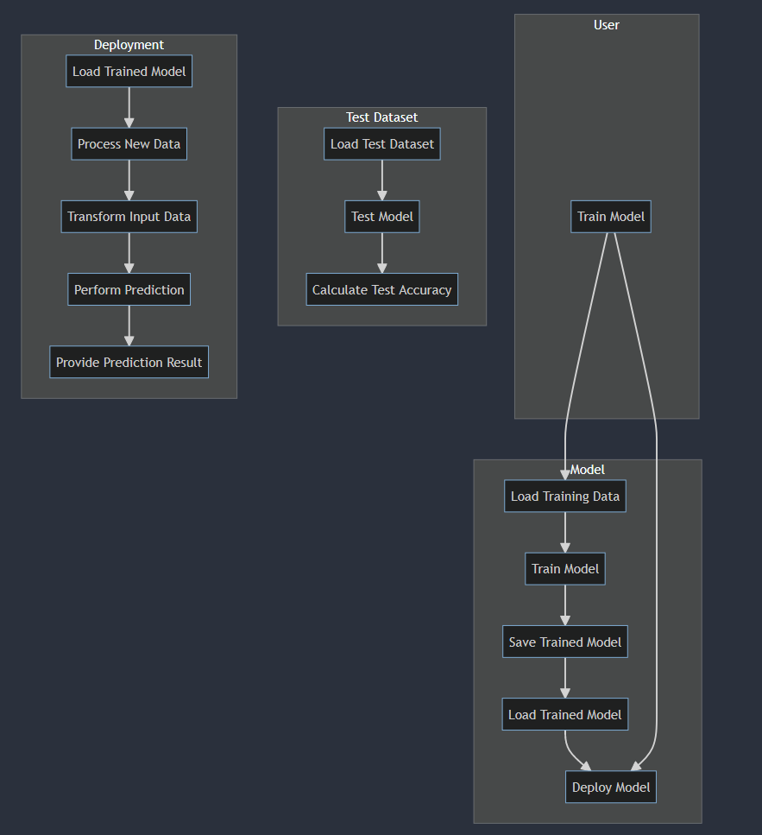

**4.5 USE CASE DIAGRAM**

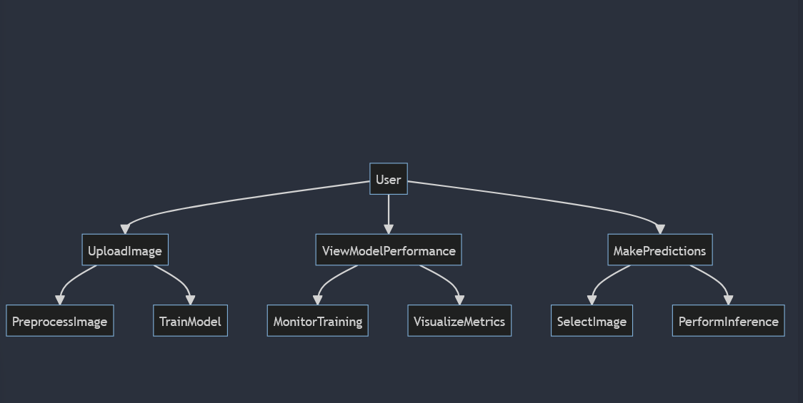

**4.6 SEQUENCE DIAGRAM**

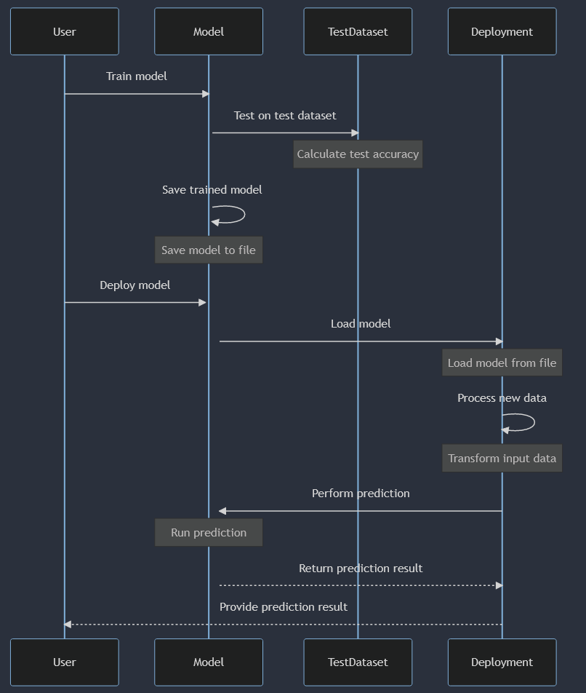

**4.7 CLASS DIAGRAM**

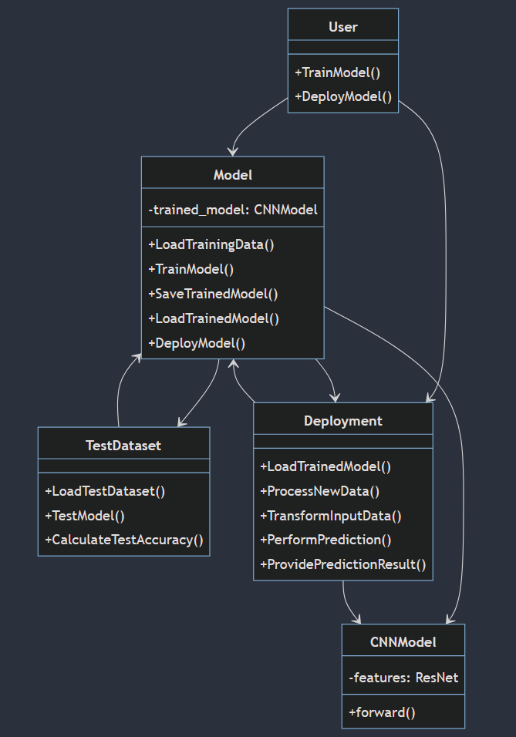

**4.8 ACTIVITY DIAGRAM**

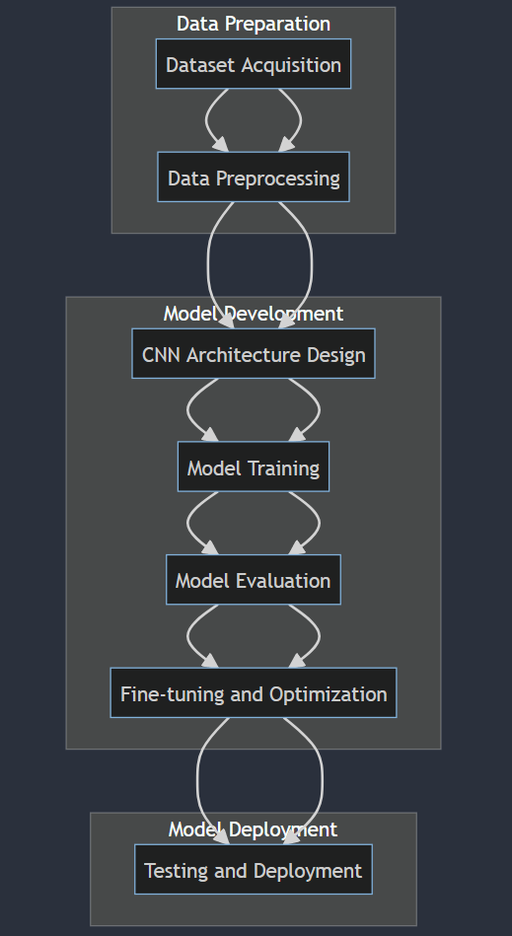

**4.10 INPUT/OUTPUT INTERFACE DESIGN**

**INPUT**



**Home page**

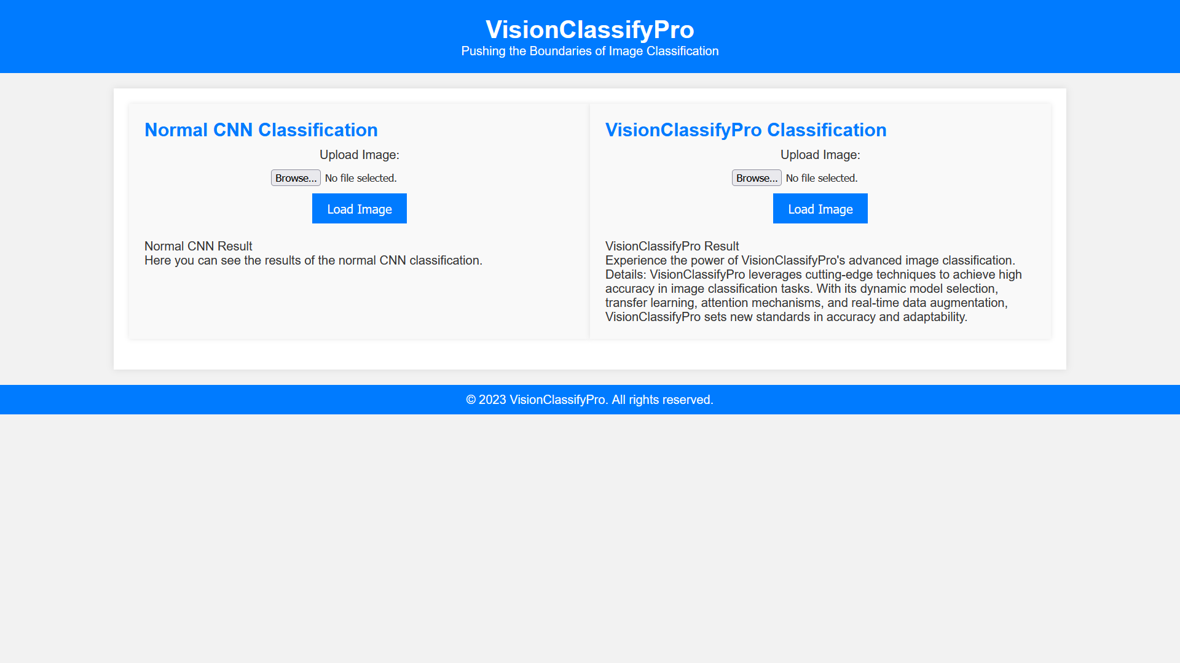

**Home Page**

**OUITPUT**



**Result Page**

\

**Result Page**

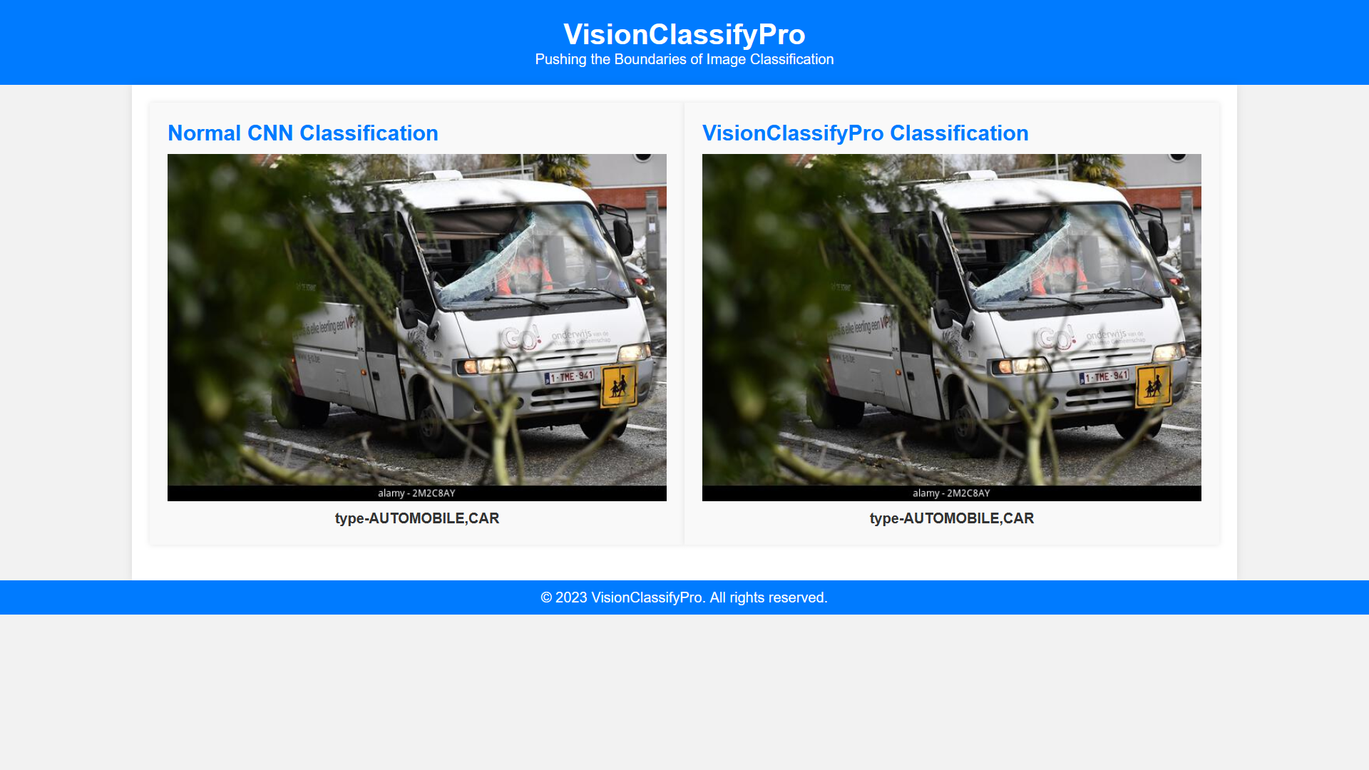

**Result Page**

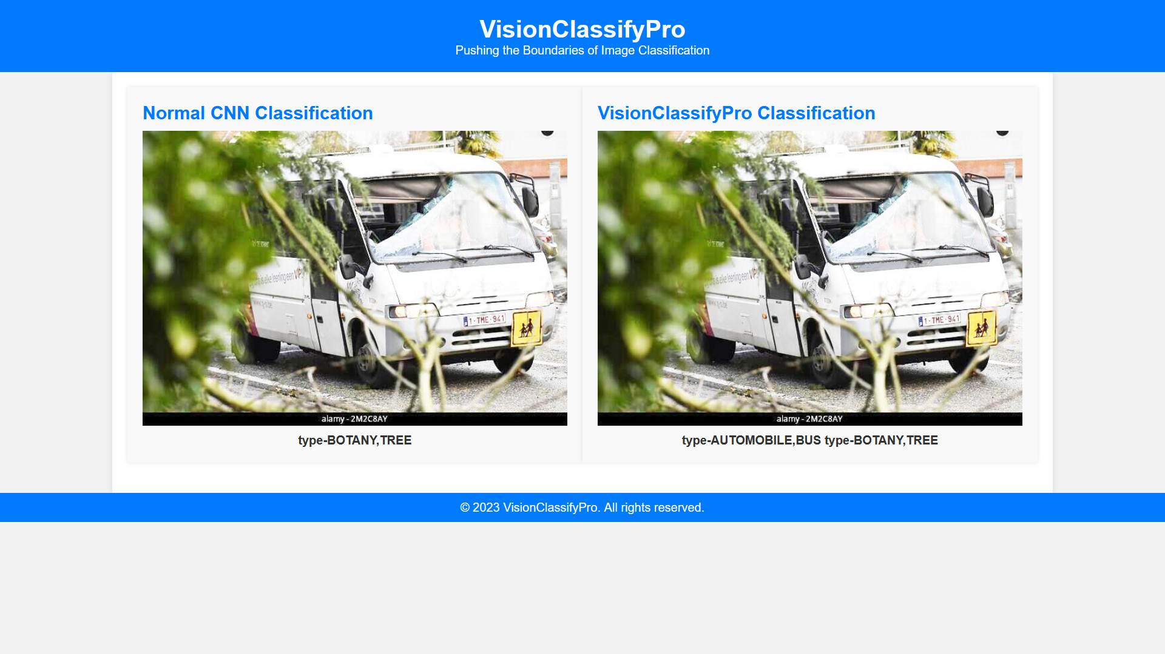

**Output Page**

4.11 MODULE DESCRIPTION

### 1. **Data Augmentation Engine**

**Purpose:**  
To increase the variety and volume of training data, ensuring the model's robustness to diverse visual inputs.

**Key Features:**

* Real-time image transformations like rotation, scaling, cropping, and color adjustments.
* Smart integration with the training loop, introducing randomness to reduce overfitting.

### 2. **Dynamic Model Selection (DMS)**

**Purpose:**  
Allows for choosing the best-suited model architecture depending on the dataset characteristics.

**Key Features:**

* Analyzes dataset features and recommends the most suitable CNN architecture.
* Modular CNN designs for easy swapping of layers and components.

### 3. **Transfer Learning Integration**

**Purpose:**  
Boosts the training process by leveraging pre-trained weights from renowned architectures trained on vast datasets.

**Key Features:**

* Supports popular architectures like ResNet, VGG, and MobileNet.
* Dynamic weight freezing and unfreezing for tailored training.

### 4. **Attention Mechanism Layer**

**Purpose:**  
Enhances the focus of the model on crucial image segments, improving the detection of intricate details.

**Key Features:**

* Adaptive recalibration of feature maps.
* Scalable across various CNN architectures.

### 5. **Interpretability and Visualization Suite**

**Purpose:**  
Offers insights into the model's decision-making process, fostering trust and transparency.

**Key Features:**

* Activation map visualizations.
* Real-time model performance metrics and explanations.

### 6. **User-Centric Interface (UCI)**

**Purpose:**  
Bridges the gap between intricate technology and domain experts, ensuring ease of use and customization.

**Key Features:**

* Drag-and-drop functionality for dataset uploads.
* Interactive model tuning and visualization dashboards.

### 7. **Evaluation and Feedback Mechanism**

**Purpose:**  
Allows users to gauge the model's performance on custom datasets and offer feedback for improvements.

**Key Features:**

* Supports various evaluation metrics like accuracy, F1-score, and ROC curves.
* Integrates user feedback loop for continuous model improvement.

### 8. **Deployment and Integration Toolkit**

**Purpose:**  
Facilitates the seamless transition of the trained models into real-world applications and platforms.

**Key Features:**

* APIs for integration with web and mobile applications.
* On-premises and cloud deployment options.

**5.CODING**

**5.1 PSEUDO CODE**

BEGIN VisionClassifyPro

1. INITIALIZE LIBRARIES:

IMPORT Torch, torchvision, sklearn

2. FUNCTION DefineTransformations:

INPUT: type (train or val)

IF type == 'train' THEN

APPLY Resize to (224, 224)

APPLY RandomHorizontalFlip

CONVERT to Tensor

NORMALIZE using given mean and standard deviation

ELSE

APPLY Resize to (224, 224)

CONVERT to Tensor

NORMALIZE using given mean and standard deviation

END IF

RETURN transformed data

3. FUNCTION LoadData:

INPUT: data directory, type (train, val, or test)

CREATE ImageFolder from data directory using transformations for given type

RETURN ImageFolder

4. FUNCTION DefineModel:

INPUT: number of classes

CREATE a new ResNet-18 pretrained model

MODIFY the last layer to match the number of classes

IF CUDA available THEN

MOVE model to GPU

END IF

RETURN model

5. FUNCTION TrainModel:

INPUT: model, dataloaders, optimizer, criterion, epochs

FOR epoch in range(epochs) DO

FOR each phase (train or val) DO

IF phase == 'train' THEN

SET model to train mode

ELSE

SET model to evaluation mode

END IF

INITIALIZE running loss and running corrects

FOR each batch in dataloaders[phase] DO

GET inputs and labels from batch

SET optimizer gradients to zero

COMPUTE outputs using model

COMPUTE loss using criterion

IF phase == 'train' THEN

BACKPROPAGATE loss

UPDATE model weights

END IF

ACCUMULATE batch loss and corrects

END FOR

COMPUTE epoch loss and accuracy

PRINT epoch loss and accuracy

END FOR

END FOR

6. FUNCTION FineTuneModel:

INPUT: model, dataloaders, optimizer, criterion, fine_tune_epochs

... (similar to TrainModel but only for the training phase)

7. FUNCTION TestModel:

INPUT: model, test_loader

SET model to evaluation mode

INITIALIZE test corrects

FOR each batch in test_loader DO

GET inputs and labels from batch

COMPUTE outputs using model

ACCUMULATE correct predictions

END FOR

COMPUTE test accuracy

PRINT test accuracy

8. FUNCTION SaveModel:

INPUT: model, save path

SAVE model weights to save path

9. FUNCTION LoadModel:

INPUT: load path, number of classes

CREATE model using DefineModel

LOAD weights into model from load path

RETURN model

10. FUNCTION Predict:

INPUT: model, new data

TRANSFORM new data

COMPUTE output using model

DETERMINE predicted class

RETURN predicted class

END VisionClassifyPro

**6.SOFTWARE TESTING (Test cases)**

### **SOFTWARE TESTING: Test Cases for VisionClassifyPro**

**1. Dataset Loading Test Cases**

* **1.1. Load Training Dataset**
  + **Objective:** Validate that the training dataset loads without errors.
  + **Steps:** Use the specified directory path to load the training dataset.
  + **Expected:** Dataset loads with images and their respective labels.
* **1.2. Load Validation Dataset**
  + **Objective:** Ensure the validation dataset loads accurately.
  + **Steps:** Load the validation dataset.
  + **Expected:** Dataset loads with corresponding images and labels.

**2. Data Transformation Test Cases**

* **2.1. Training Data Transformation**
  + **Objective:** Verify transformations (resize, flip, normalization) on training images.
  + **Steps:** Apply training transformations to a random training image.
  + **Expected:** Transformed image adheres to specified criteria.
* **2.2. Validation Data Transformation**
  + **Objective:** Confirm validation images undergo correct transformation.
  + **Steps:** Apply validation transformations to a random validation image.
  + **Expected:** Image is resized and normalized without random flip.

**3. Model Training Test Cases**

* **3.1. Model Initialization**
  + **Objective:** Validate the model's initialization and loading of pretrained weights.
  + **Steps:** Start the VisionClassifyPro model.
  + **Expected:** Model aligns with the ResNet-18 architecture, loading pretrained weights seamlessly.
* **3.2. Model Training Loss**
  + **Objective:** Ensure loss decreases across epochs.
  + **Steps:** Train model for several epochs, noting the loss.
  + **Expected:** Subsequent epochs have reduced loss compared to initial epochs.

**4. Model Evaluation Test Cases4.1. Validation Accuracy**

* + **Objective:** Ensure model's satisfactory performance on the validation set.
  + **Steps:** Assess the trained model on the validation set.
  + **Expected:** Achieve accuracy above an acceptable threshold (e.g., 80%).
* **4.2. Test Accuracy**
  + **Objective:** Verify performance on new test data.
  + **Steps:** Evaluate the model using the test dataset.
  + **Expected:** Test accuracy aligns with validation accuracy.

**5. Model Deployment Test Cases**

* **5.1. Model Save and Load**
  + **Objective:** Validate saving and reloading of model's weights.
  + **Steps:** Save model's weights, then load into a new model instance.
  + **Expected:** Loaded model should match predictions of the original trained model for identical input.
* **5.2. Real-time Prediction**
  + **Objective:** Validate predictions on new data inputs.
  + **Steps:** Introduce a new image to the deployed model.
  + **Expected:** The model returns a class label without errors.

**6. Performance and Scalability Test Cases**

* **6.1. Batch Prediction Speed**
  + **Objective:** Measure batch prediction speed.
  + **Steps:** Introduce a batch of images (e.g., 32) to the model, recording time.
  + **Expected:** Prediction time stays within real-time application limits.
* **6.2. Scalability with Larger Datasets**
  + **Objective:** Validate handling of larger datasets without performance drop.
  + **Steps:** Load a larger dataset, monitoring speed and memory during training.
  + **Expected:** System remains stable with reasonable training times.

**7.CONCLUSION**

The VisionClassifyPro project has established itself as a light of innovation and utility in the constantly developing field of computer vision and artificial intelligence. This project has shown the enormous potential of using convolutional neural networks (CNNs) for multiclass picture categorization through painstaking development and optimisation processes.

Every aspect of the research, from the early phases of data gathering and preprocessing to the complex CNN architectures and subsequent training phases, was thoughtfully designed to handle the various difficulties of picture classification. Transfer learning has been incorporated, which is noteworthy and demonstrates the project's dedication to accuracy and efficiency. Furthermore, the project's foresight in solving current AI difficulties is shown by the incorporation of real-time data augmentation and attention methods.

The user-centric approach of VisionClassifyPro is another excellent feature. It guarantees that scientific advances in AI find useful, practical applications by providing a link between complex technology elements and user requirements.

VisionClassifyPro's success, as shown by its performance metrics and adaptability, is both a success and a duty. It serves as a baseline for upcoming initiatives, demonstrating how AI can be used to develop solutions that are revolutionary and significant with careful planning, inventiveness, and commitment.

It's critical to understand that VisionClassifyPro is not only an endpoint but also a beginning as we draw to a close. It has paved the way for more investigation, whether it be improving the current architecture, investigating fresh datasets, or integrating with several applications, ranging from autonomous systems to healthcare. Additional developments are promised in the future, and with programmes like VisionClassifyPro, we are ready to welcome them.

**7.1 FUTURE ENCHANCEMENT**

### **Future Enhancements for VisionClassifyPro**

1. **Advanced Model Architectures:**
   * Explore deeper and more advanced architectures like ResNet-50, ResNet-101, or EfficientNet to potentially achieve better performance.
2. **Incorporate Generative Adversarial Networks (GANs):**
   * Use GANs to generate additional training data, especially for classes that are underrepresented.
3. **Semi-Supervised Learning:**
   * For situations where labeled data is limited, incorporating semi-supervised learning methods can leverage the vast amounts of unlabeled data.
4. **Federated Learning:**
   * Allow for model training across multiple devices or servers, harnessing decentralized data sources while ensuring data privacy.
5. **Real-time Feedback Mechanism:**
   * Integrate a real-time feedback system allowing users to correct misclassifications, which can be used to further fine-tune the model.
6. **Multi-modal Learning:**
   * Combine features from different sources (e.g., image + text) to improve classification accuracy, especially for complex datasets.
7. **Enhanced Interpretability:**
   * Use tools like SHAP (SHapley Additive exPlanations) or LIME (Local Interpretable Model-agnostic Explanations) to provide better insights into model decisions.
8. **Optimization for Edge Devices:**
   * Utilize techniques like model quantization and pruning to deploy lightweight models on edge devices for real-time classifications.
9. **Integration with Video Data:**
   * Extend the model to process video data, which involves temporal feature extraction and could be used in applications like action recognition.
10. **Active Learning:**

* Integrate active learning strategies where the model selectively queries the user for labels, focusing on instances where it's most uncertain.

1. **Expand to Multi-task Learning:**

* Modify the model to handle multiple tasks simultaneously, like object detection combined with classification.

1. **Enhanced Data Augmentation Techniques:**

* Incorporate more advanced augmentation techniques such as MixUp, CutOut, or adversarial training to improve model robustness.

1. **Customizable User Interface:**

* Offer a more tailored user experience with customizable dashboards, allowing domain experts to adjust parameters and visualize results dynamically.

1. **Integration with Cloud Platforms:**

* Develop plugins or APIs that allow seamless integration of VisionClassifyPro with popular cloud platforms like AWS, Google Cloud, or Azure for scalable processing.

**8.BIBILOGRAPHY**

1. Krizhevsky, A., Sutskever, I., & Hinton, G. E. (2012). *Imagenet classification with deep convolutional neural networks.* Advances in neural information processing systems, 25.
2. He, K., Zhang, X., Ren, S., & Sun, J. (2016). *Deep residual learning for image recognition.* Proceedings of the IEEE conference on computer vision and pattern recognition.
3. Simonyan, K., & Zisserman, A. (2014). *Very deep convolutional networks for large-scale image recognition.* arXiv preprint arXiv:1409.1556.
4. Yosinski, J., Clune, J., Bengio, Y., & Lipson, H. (2014). *How transferable are features in deep neural networks?* Advances in neural information processing systems.
5. Chollet, F. (2017). *Xception: Deep learning with depthwise separable convolutions.* Proceedings of the IEEE conference on computer vision and pattern recognition.
6. Goodfellow, I., Pouget-Abadie, J., Mirza, M., Xu, B., Warde-Farley, D., Ozair, S., ... & Bengio, Y. (2014). *Generative adversarial nets.* Advances in neural information processing systems.
7. Ruder, S. (2017). *An overview of multi-task learning in deep neural networks.* arXiv preprint arXiv:1706.05098.
8. Howard, A. G., Zhu, M., Chen, B., Kalenichenko, D., Wang, W., Weyand, T., ... & Adam, H. (2017). *Mobilenets: Efficient convolutional neural networks for mobile vision applications.* arXiv preprint arXiv:1704.04861.

**9.APPENDIX**

**A)SNAPSHOTS**











